Make Sure you have MetaMask installed.

Go to ⇒ <https://www.myetherwallet.com/access-my-wallet>

Choose MetaMask Option

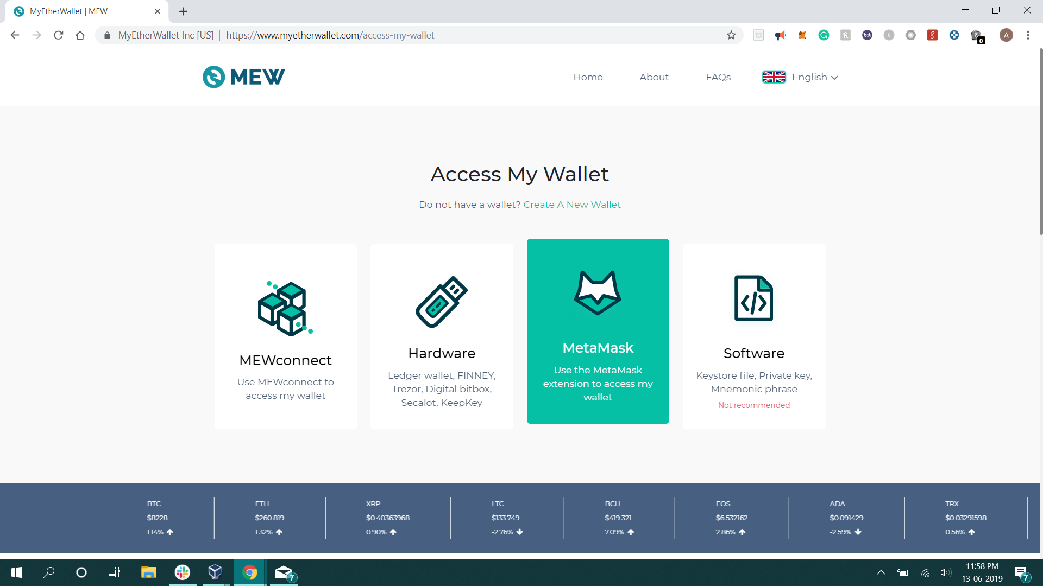

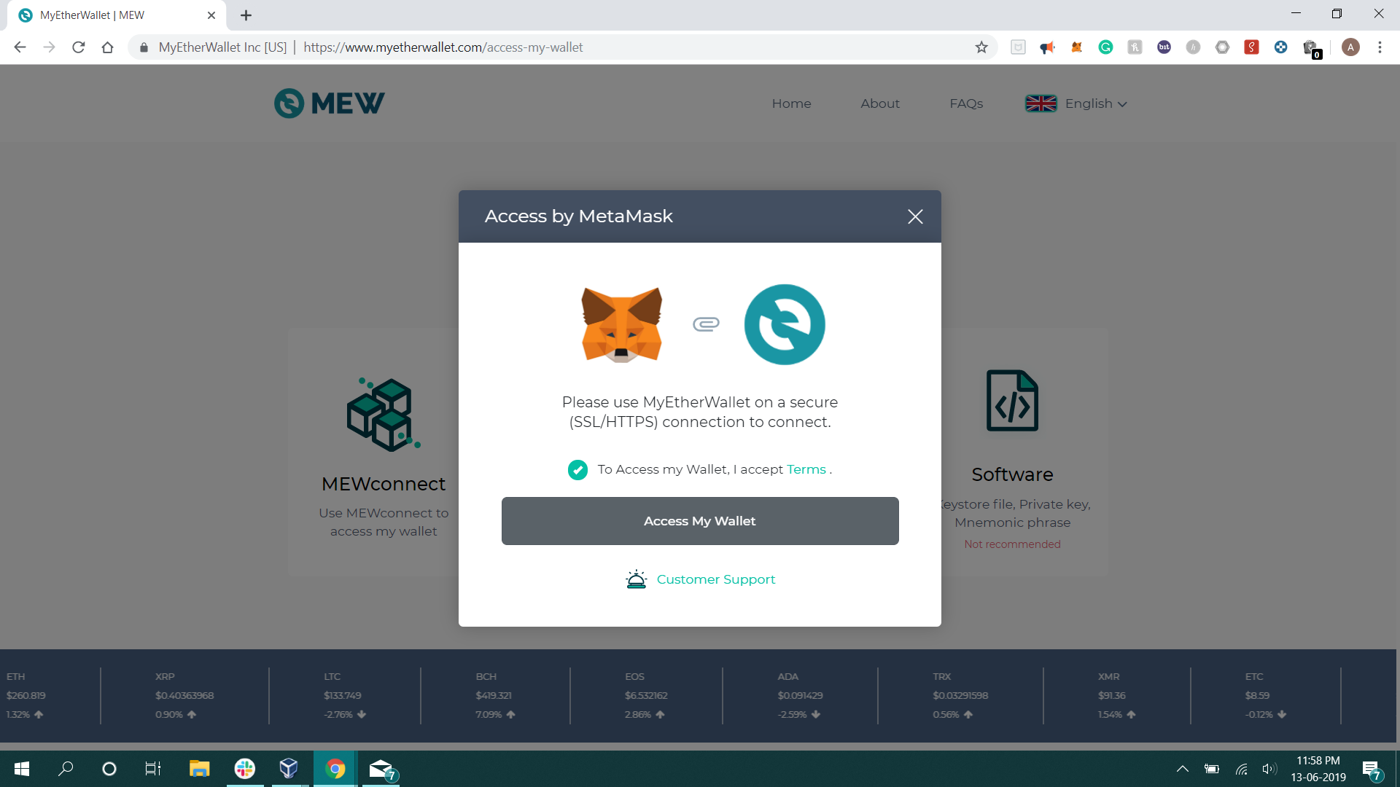

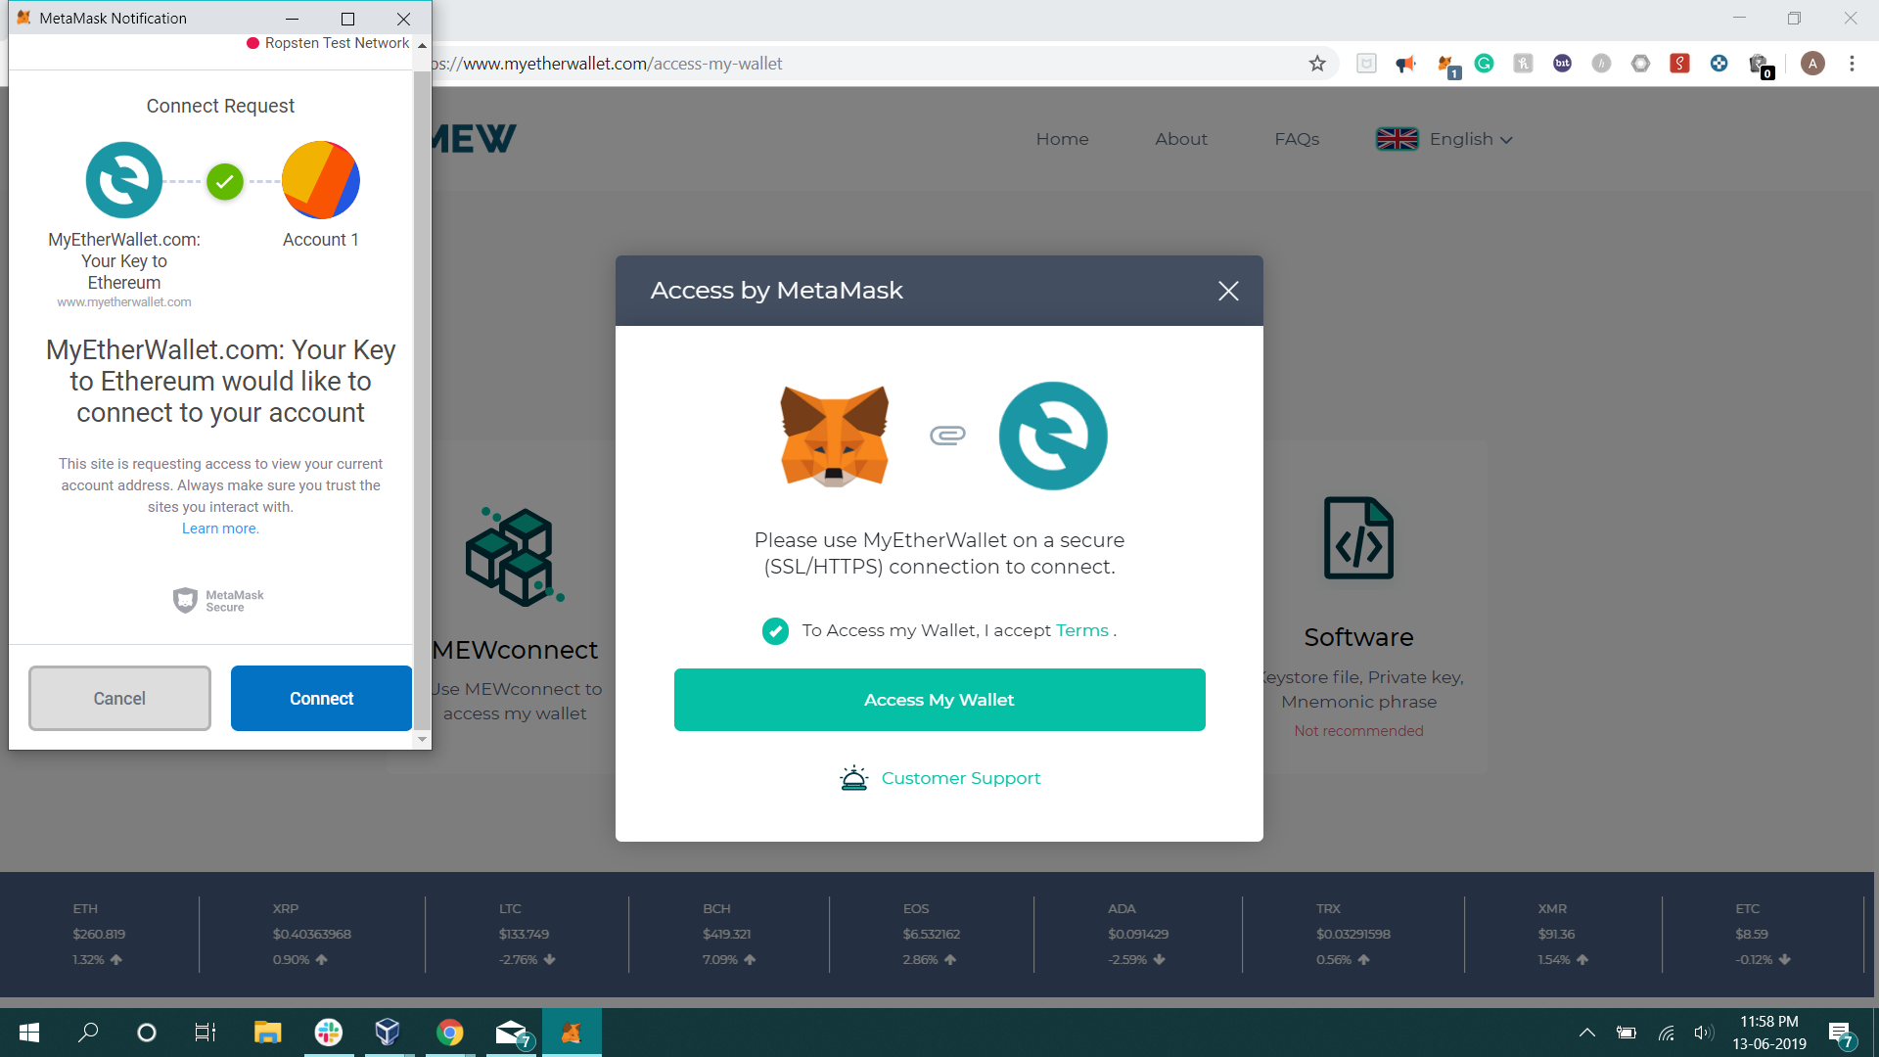

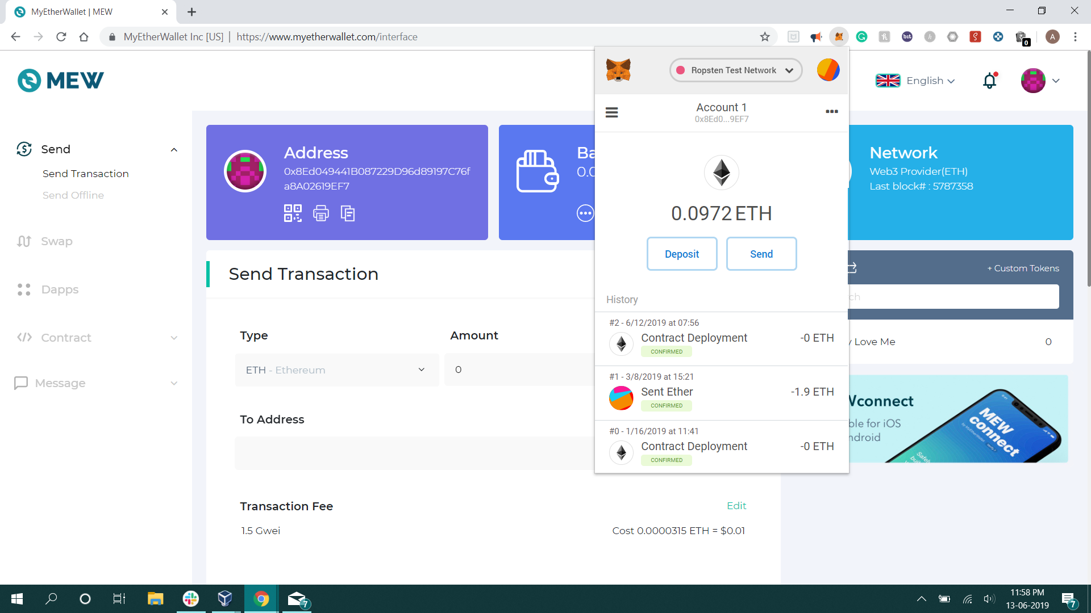

Change MetaMask NetWork to Ropsten Test Network

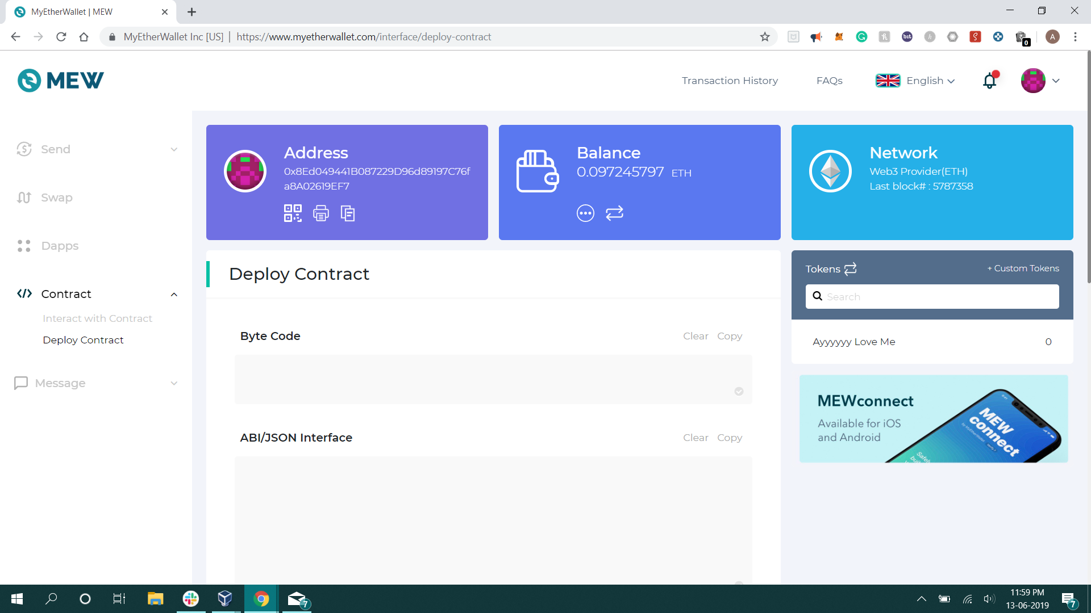

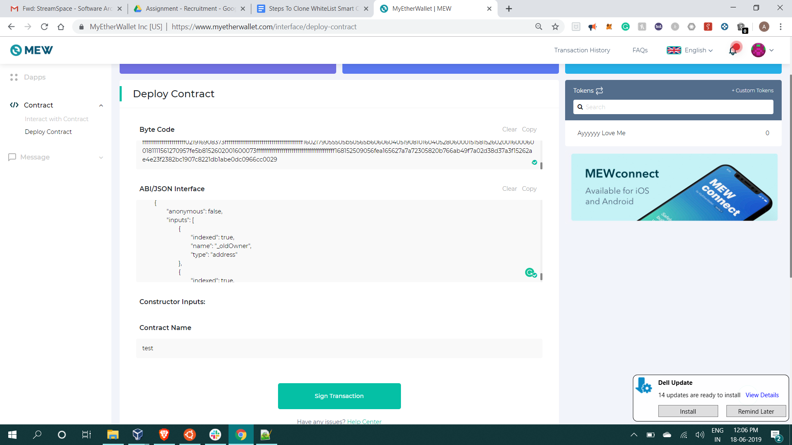

Go to Contract ⇒ Deploy Contract

Past the Given ByteCode And ABI and Deploy to the contract.

Then click Sign Transaction

Make sure you are using Test Net.

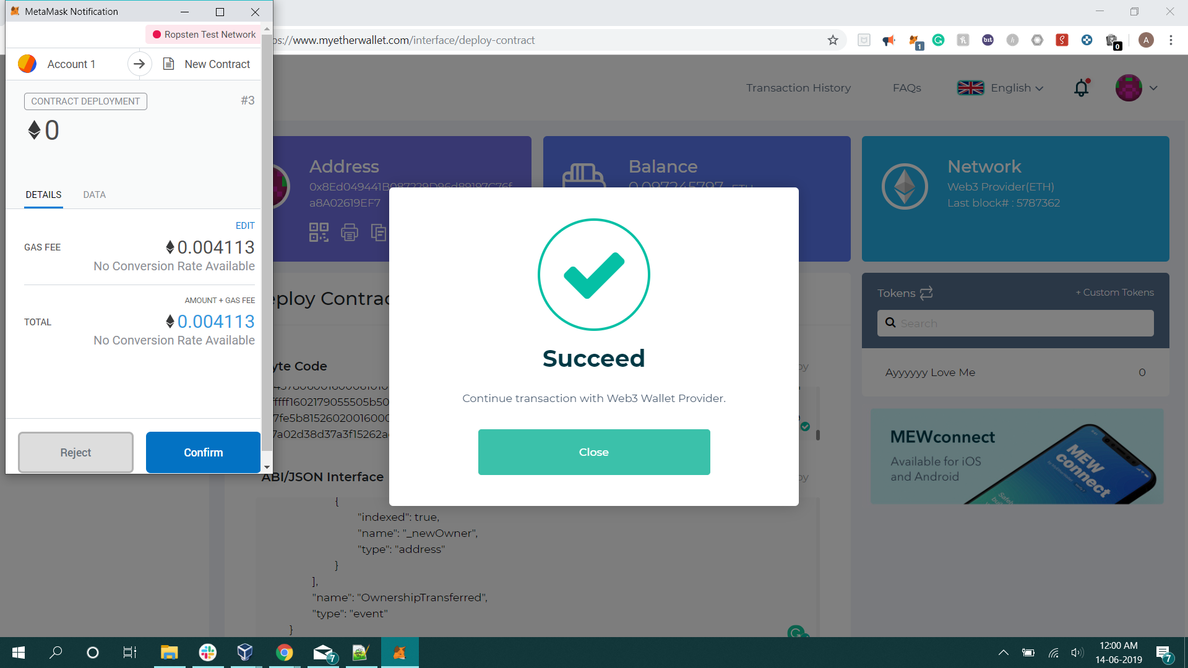

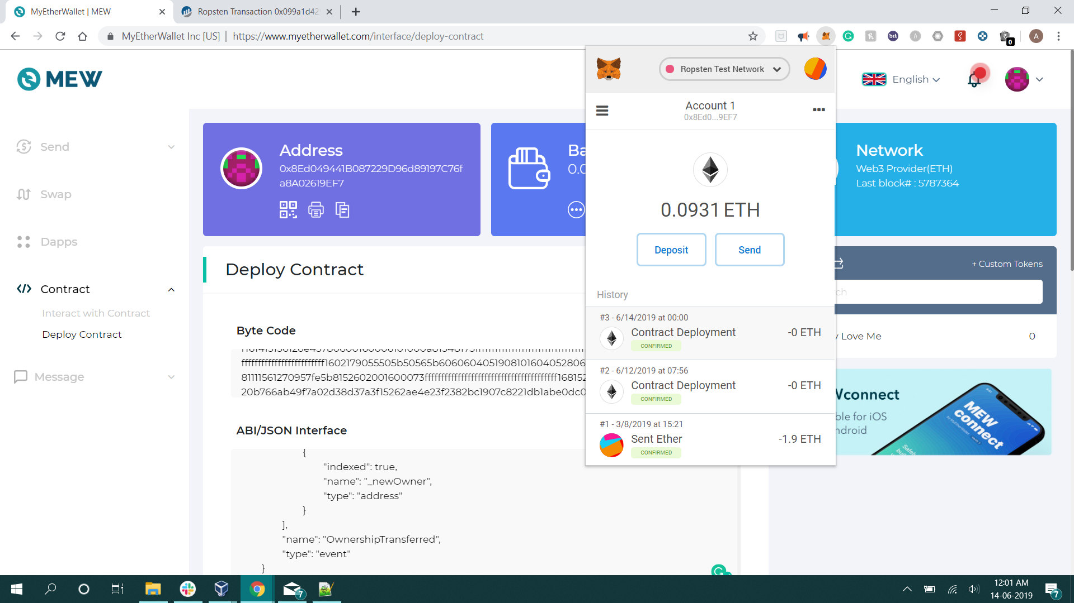

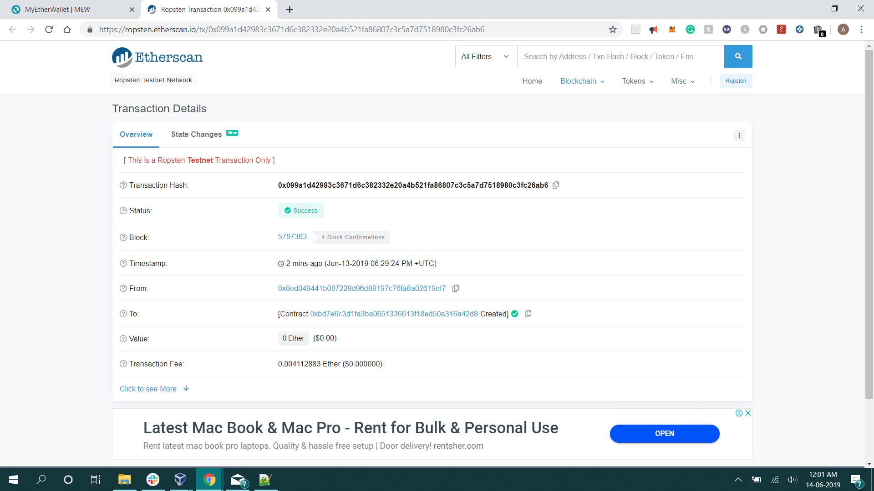

To Interact with Smart Contract GO TO: Contract ⇒ Interact With Contract

Past the contract address, ABI and click continue

